**HOSTEL MANAGEMENT SYSTEM**

# STRUCTURE OF THE SYSTEM:

This system design is divided into two section or portion. Administrator and student section.

## Administrator:

1. He can register in the system.
2. Also can login.
3. He can control the student payment.
4. He can edit the detail of the students.
5. Make hostel bill.

## Student:

* Student registration.
* Login system.
* View room details.
* Book hostel.
* Send complains.

## Data flow diagram:

* Whole process of system:

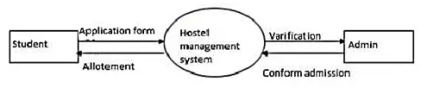

## ERD:

## Use case diagram:

## Database:

# ABOUT THE SYSTEM:

* Security used:
* Run at local host:
* Backend language used:
* Frontend language used: